Post - 1
Delivered a keynote session on “Real World #Blockchain Use Cases and Future Trends” during the One Week National Level FDP on “Blockchain Ecosystem: Research, Innovation, Applications, and SDG Integration” organized by the Department of Information Technology, Marathwada Mitra Mandal’s College of Engineering in association with IEEE Pune Blockchain Group.
It was a wonderful opportunity to interact with faculty members, researchers, and blockchain enthusiasts and discuss the transformative impact of blockchain across various domains and recent trends.
The session also highlighted:
- Real time use cases
- IEEE Blockchain Standards
- Future Trends –
  - Blockchain and Quantum Computing
  - AI and Blockchain
#Blockchain #FDP #IEEE
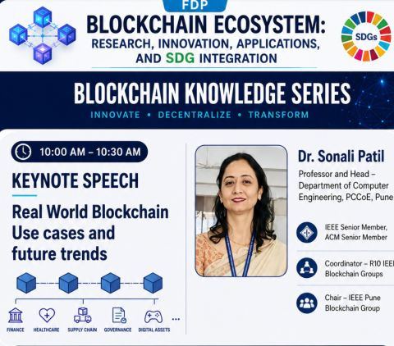

Post -2 reposted blockchain podcast
What happens when Blockchain, AI, and Education come together? 🚀

I had an inspiring conversation with Dr. Sonali D. Patil, ma’am, where we explored how technology is not just transforming industries—but shaping the future of students, trust, and innovation 🌐

From reducing fraud using Blockchain 🔐 to building trustworthy AI systems using decentralized identity 🤖, this podcast uncovers how emerging technologies are creating real-world impact.

We also discussed why continuous learning 📚, hackathons 💡, and practical experience 🛠️ are the true game-changers for students today.

One powerful takeaway: Technology alone is not enough. The mindset to learn, question, and build is what creates real innovators ⚡

If you are a student 👨‍🎓, developer 👨‍💻, educator 👩‍🏫, or tech enthusiast — this conversation will change how you see the future of Blockchain and AI.

🎥 Watch the full podcast here: https://lnkd.in/gUJyJYtJ

Let’s build, learn, and innovate together! 🚀

PCCOE PUNE Pimpri Chinchwad College of Engineering & Research (PCCOER) PCCOE ACM Student Chapter ManoRekha.com PCCOER ACM STUDENT CHAPTER
#Blockchain #AI #Podcast #Education #Web3 #Innovation #Students #AkshayKurhekar #Technology #Future
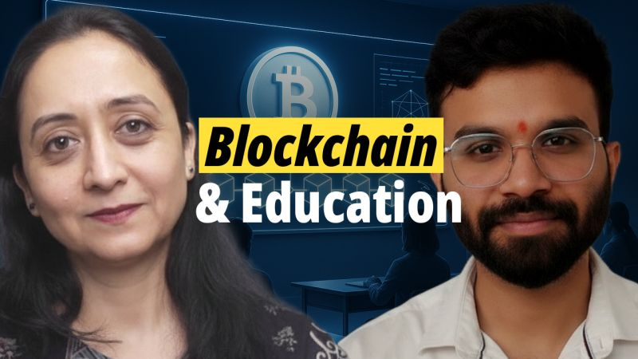
Post -3
Glad to be part of the inaugural session as Guest of Honour of the week-long Faculty Development Program (1st Dec to 5th Dec 2025) on "#Blockchain for #Sustainable Development: Innovations, Applications, and Future Directions” organized by the Department of Information Technology, @MMCOE Pune, in association with the IEEE Pune Blockchain Group.

As the Chair of the IEEE Pune Blockchain Group, it was wonderful to witness the growing interest and impactful discussions on the role of Blockchain in Sustainable Development.

This FDP aims to explore how blockchain can drive transparency, trust, and sustainability across key sectors such as governance, energy, circular economy, and smart ecosystems — a theme deeply aligned with the vision of the global IEEE Blockchain Technical Community.

Heartfelt appreciation to the organizers for their excellent coordination and warm welcome.
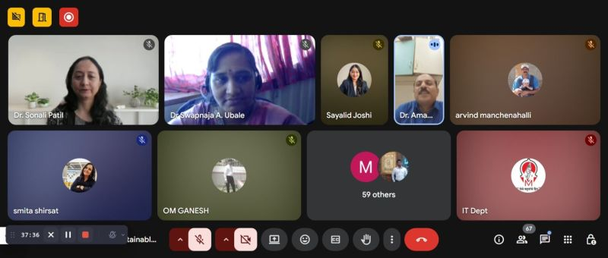
#IEEE #IEEE_Blockchain #IEEE_Pune_Blockchain #Sustainability #PCCOE #MMCOE
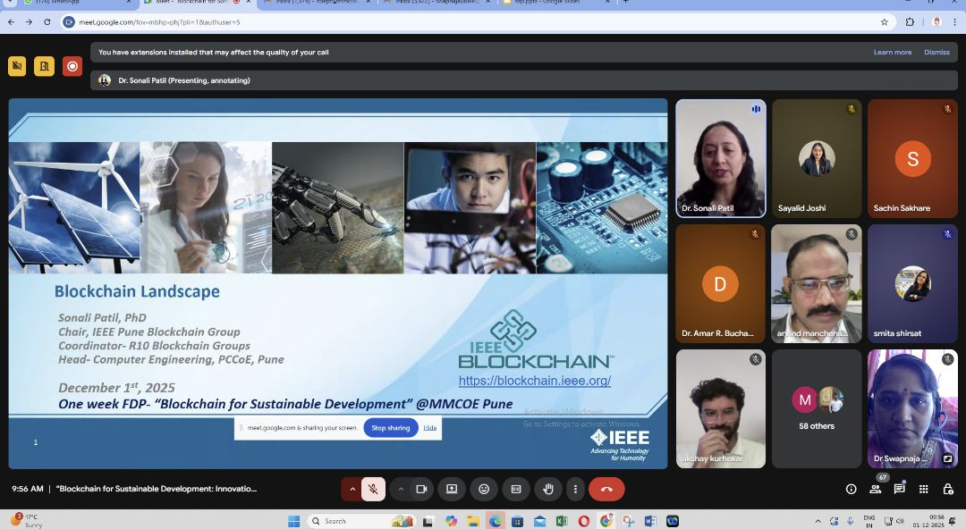

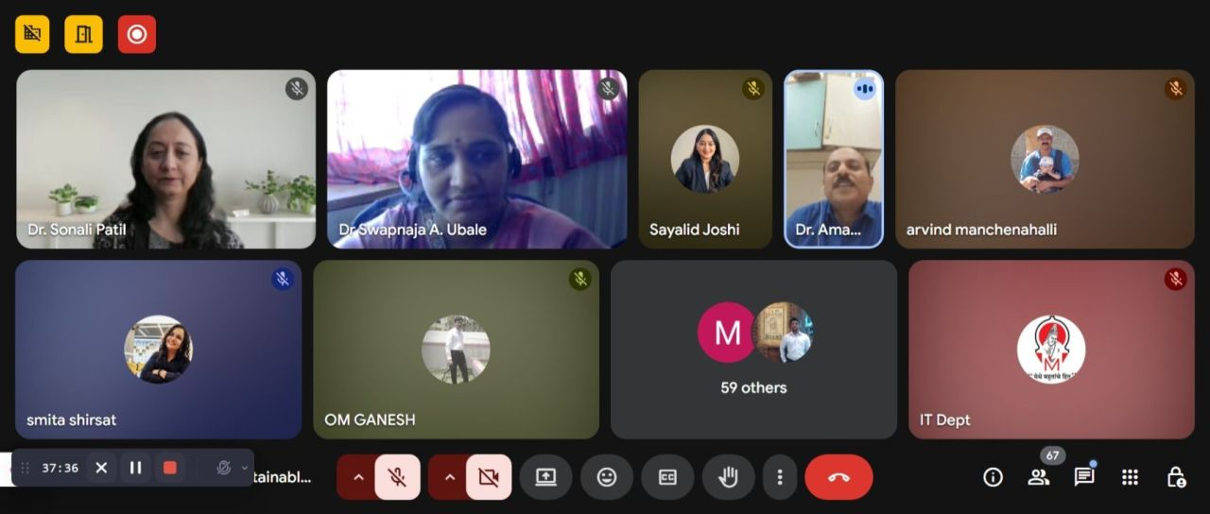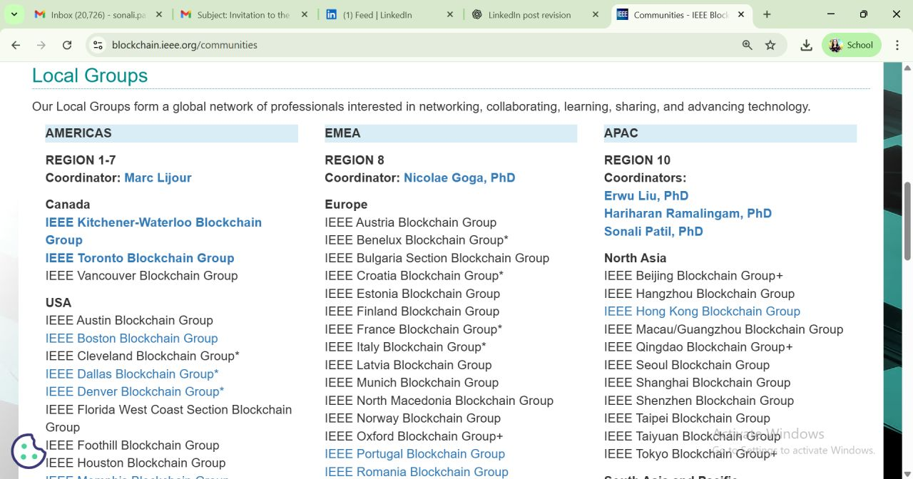

Post-4
Happy to be a panel member for “Role of Academia in Blockchain Adoption” organised by Linux Foundation Decentralized Trust India Chapter, Citi India and India Blockchain Forum at Citi, EON IT Park, Pune.

Honored to be part of the planning team of the Finance Hackathon - 1000+ participants, 250+ teams from academia, startups & MNCs! It was D_day of Finale, Keynote session, expert talks and panel discussions.

Grateful to be part of this journey of innovation & collaboration.
#LFDT #India_Blockchain_Forum #Citi

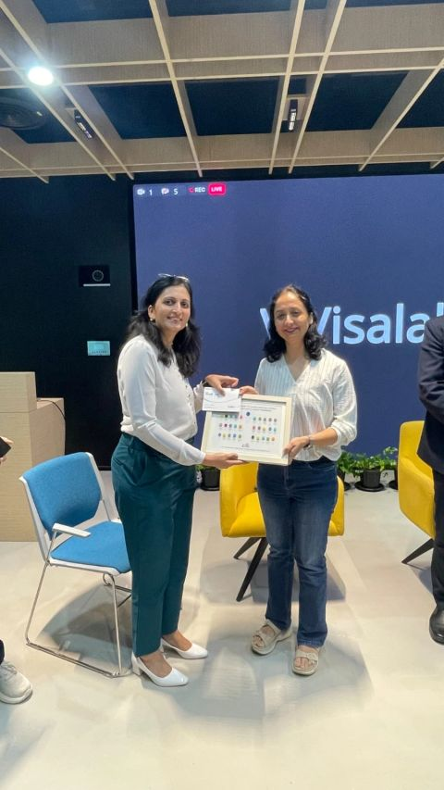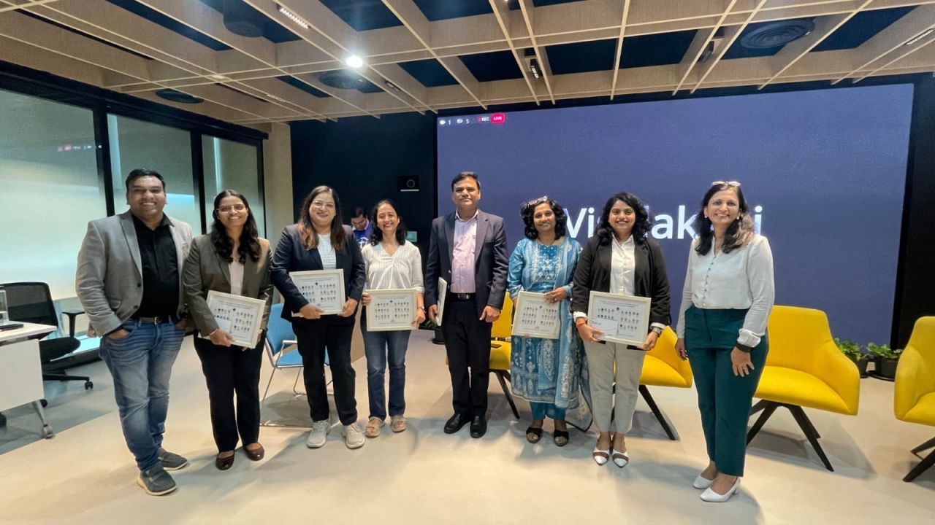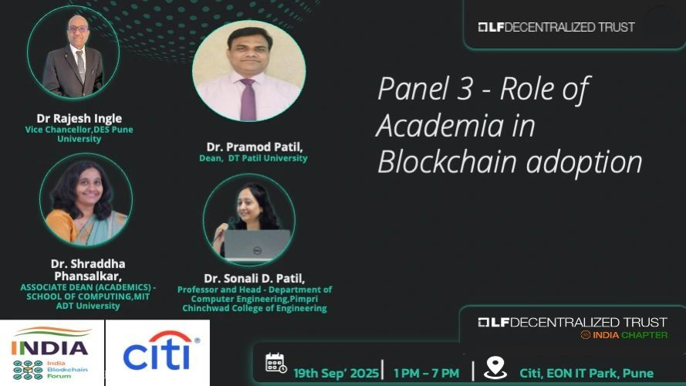

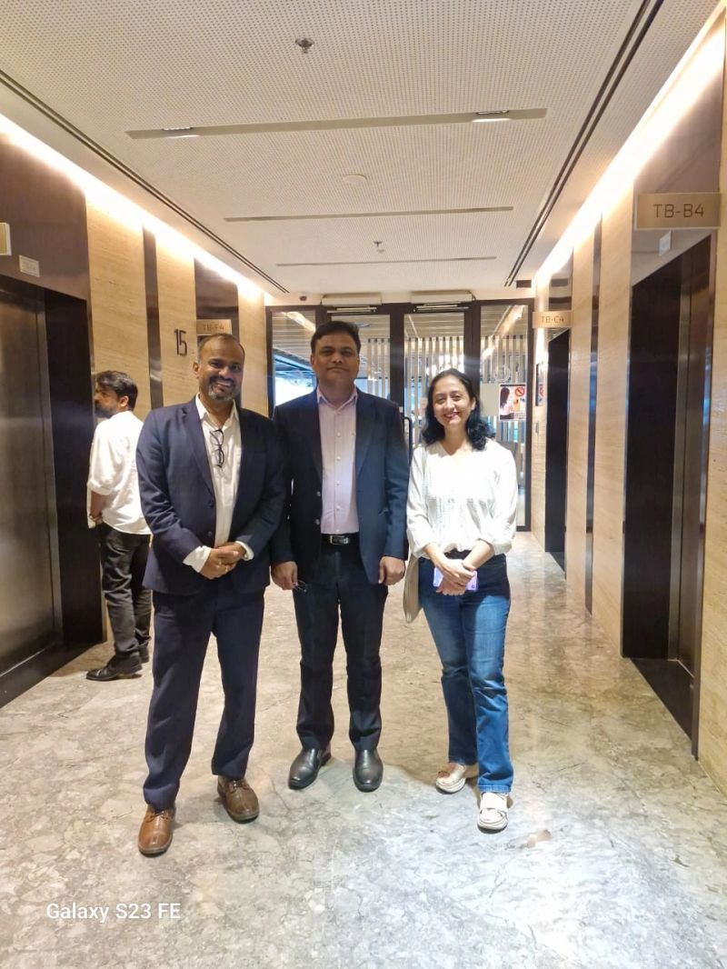

Post- 5
One-Week Faculty Development Program (FDP) on Decentralized AI, scheduled from 18th – 25th August 2025 (Online Mode).

The FDP is organized by IEEE Pune Blockchain Group and Pimpri Chinchwad College of Engineering Pune in collaboration with IEEE Pune Section, IEEE Computer Society Pune chapter and IEEE Blockchain Technical Community.

Join us to explore cutting-edge advancements in AI, Agentic Web, Multiagent Collaboration, Web3, Blockchain, Federated Learning, Verifiable AI, and decentralized technologies with our panel of experts from Industry and academia.
Anantha R K. – Founder & CEO, Sarva Labs
Dr. Rajesh Ingle – Vice Chancellor, DES Pune University; Chair, IEEE Computer Society Chapter Pune
Kamlesh Nagware – Blockchain Architect, Founder, FSV Lab
Ravikant Agrawal – Director, Privado ID
Vidy Potdar – Director, Blockchain Research & Development Lab, Curtin University, Australia
Dr. Sonali D. Patil - Professor and Head- Computer Engineering, PCCOE, Chair, IEEE Pune Blockchain Group
Ankita Patidar – Tech Lead, AYANWORKS; Co-Chair, Hyperledger India Chapter

Let's Come together to unlock the future of AI- Decentralized, Secure and Collaborative!
#IEEE #IEEE_Blockchain #PCCOE #Decentralized_AI
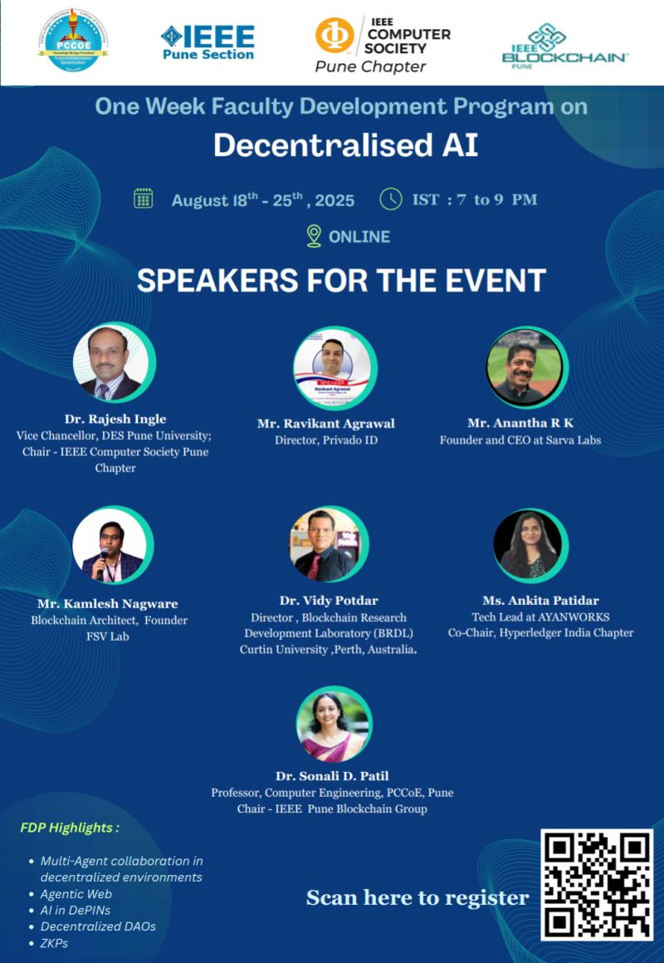
Post-6
Happy to announce the release of our edited book:
"Decentralized Healing: Transforming Healthcare with Federated Learning and Blockchain Technologies" Published by CRC Press Taylor& Francis Group.

This book brings together interdisciplinary insights on how emerging technologies like Federated Learning and Blockchain are reshaping the future of healthcare - ensuring security, privacy, and decentralized control in data-driven medical systems.

Honored to co-edit alongside Dr. Rajesh Ingle, Dr. Amar Buchade, and Vidy Potdar.

A big thank you to all contributors, researchers, and visionaries who made this possible. Grateful for this collaboration and the opportunity to contribute to this emerging field.

#FederatedLearning #Blockchain #BlockchainInHealthcare #CRCPress
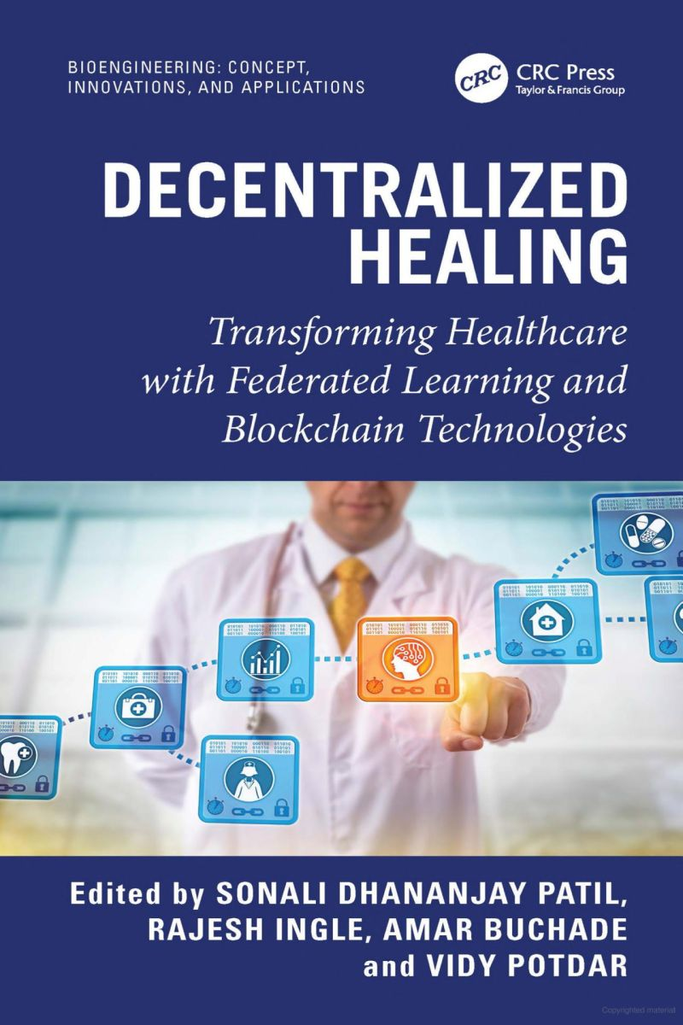

Post-7
Ready to innovate in blockchain?

Join a high-impact Blockchain Hackathon and build real-world solutions in Blockchain, DeFi, CBDCs, RWAs, Defi and Compliance Tech.

🗓️ Register by 30th July 2025 👉 https://lnkd.in/gtQQiXpG

Let’s shape the future of finance!

#Blockchain #Hackathon #Fintech #Web3 #Innovation #India #ConsensusCircle
Blockchain CoP | Consensus Circle
LF Decentralized Trust India Chapter Kamlesh Nagware Prasanna Lohar Garima Singh Yogesh Karandikar Dr. Deepankar Roy

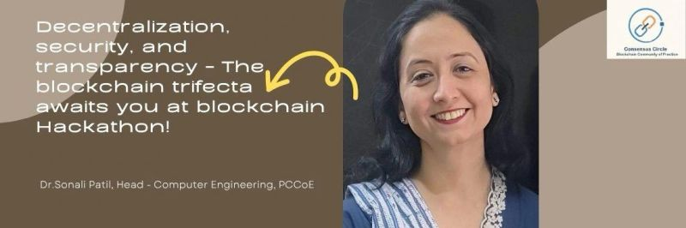

Post-8
Happy to deliver a session on "Blockchain & Cryptocurrency: The future of Fintech Trends" at the prestigious 7th International Symposium on Innovative Global Technology Trends organized by the College of Management, MIT-ADT University on 20th March 2025.

The event was a fantastic platform to discuss the evolving landscape of blockchain, its impact on the financial sector, and its future potential.

#Blockchain #Cryptocurrency #Fintech #IEEE

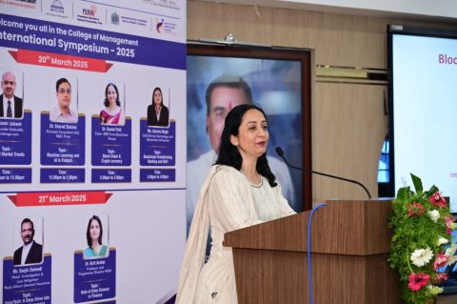
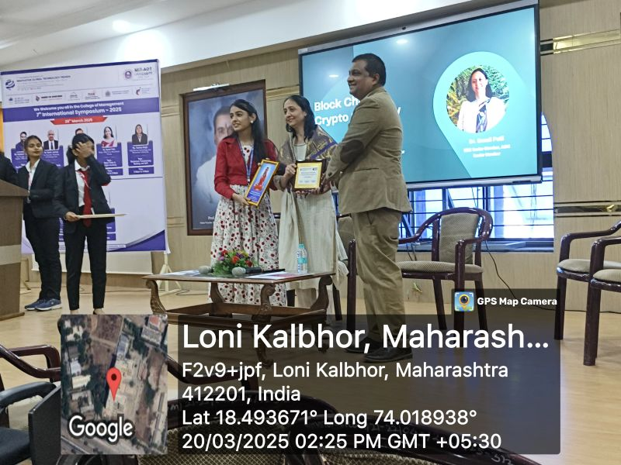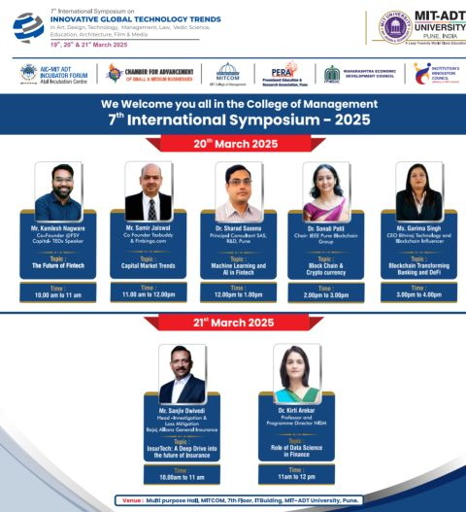

Post - 9
Delivered a session on "Evolution of Blockchain and Research Opportunities" on 22nd Feb 2025 as part of the One-Week Faculty Development Program (FDP) on "Research Directions in Information Security and Blockchain"

The FDP was organized by IEEE Pune Blockchain Group and the Department of Computer Engineering, PCCoE, Pune to explore cutting-edge advancements in Blockchain and Cybersecurity research. It was a pleasure interacting with enthusiastic faculty members and researchers, discussing emerging trends, challenges, and future directions in this transformative technology.

PCCOE PUNE IEEE Pune Blockchain Group IEEE Blockchain Technical Community IEEE Pune Section

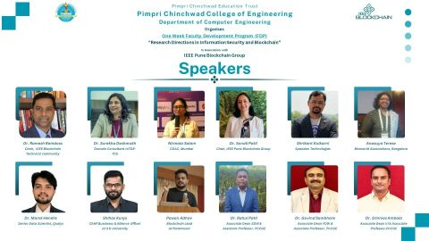
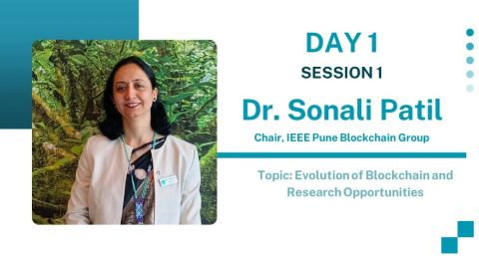

Post - 10
I had the privilege of delivering an expert session on "Automated Vulnerability Detection for Smart Contracts in Blockchain" during the AICTE Sponsored ATAL Faculty Development Program (FDP) on "Navigating the Future of Decentralized Advanced Blockchain Technologies" at Fr. Conceicao Rodrigues College of Engineering (FCRCE), Bandra (W), Mumbai.
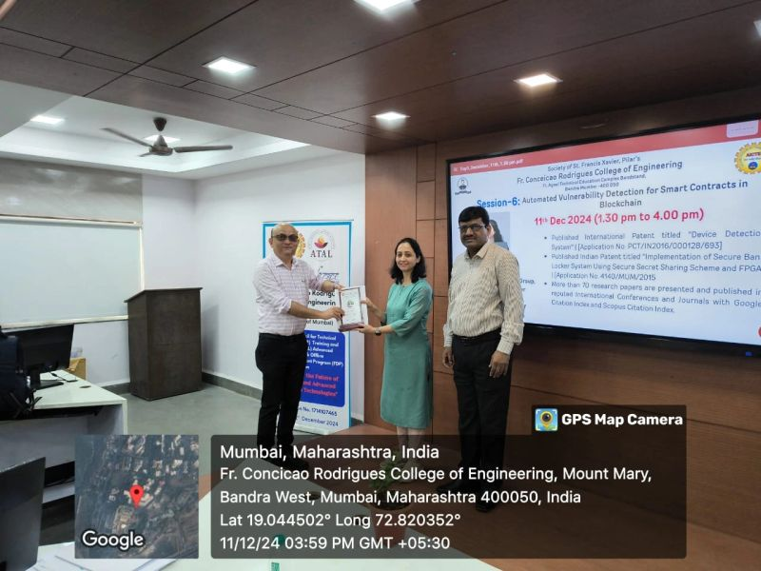
#Blockchain #pccoe #fsrcoe #fdp
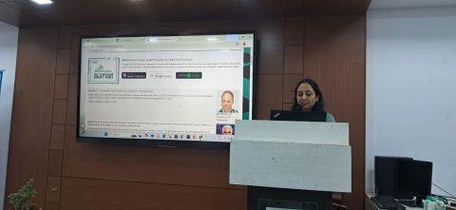
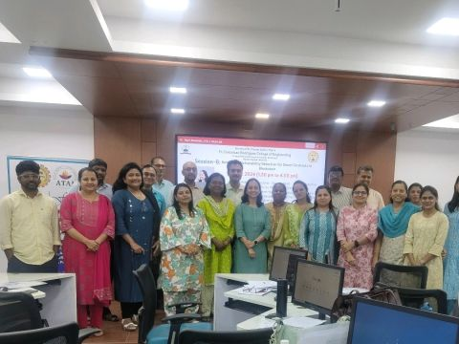

Post - 11
Delivered a session at the one-week Faculty Development Program (FDP) on "Blockchain: The Next Frontier in Cybersecurity and Privacy," organized by Marathwada Mitra Mandal College of Engineering (MMCOE) in collaboration with IEEE Pune Blockchain Group from August 20th to 24th, 2024.

The IEEE Pune Blockchain Group remains dedicated to supporting and advancing blockchain-related activities. We are thrilled to contribute to initiatives that drive innovation in this critical field through collaborations with various organizations.

Looking forward to many more fruitful collaborations!

Many thanks to Chair- IEEE Blockchain Ramesh Ramadoss, PhD and Chair- IEEE Pune Section Dr Surekha Deshmukh for their encouragement and support.

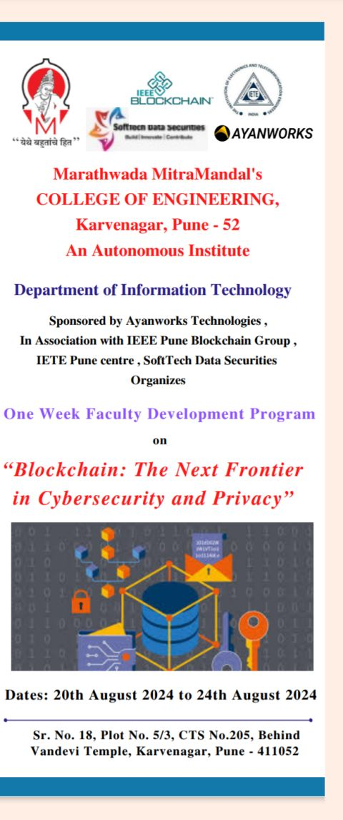
#Blockchain #IEEE #PCCOE #IEEE_Pune_Blockchain_Group #BCTC

Post- 12
Successful organization of an ISTE approved 6-day (15th July to 20th July 2024) STTP on "Emerging Trends in #Blockchain" by the #Computer_Engineering Department #PCCoE and Computer Engineering -Regional Department PCCoE in association with IEEE Pune Blockchain Group.

The event was a remarkable success, featuring #insightful_discussions, #practical_demonstrations, and #realtime_use_cases, providing an enriching experience to all the participants.

Special thanks to IEEE Blockchain, IEEE Pune Professional Chapter, and CDAC Mumbai for their invaluable support and guidance. I also extend my heartfelt gratitude to the PCET management, Executive Director PCET Dr. Girish Desai Sir, Director PCCoE Dr. Govind Kulkarni Sir and Deputy Director PCCOE Dr. N. B. Chopade Sir for their unwavering motivation and support.

We were thrilled to have 153 participants from various states across the nation join us for this incredible learning experience.

Thank you to all the speakers, participants and my organizing team members for making this event a grand success! 🌟

Ramesh Ramadoss, PhD | Dr Surekha Deshmukh | Dr Padmaja Patwardhan Joshi | Kamlesh Nagware
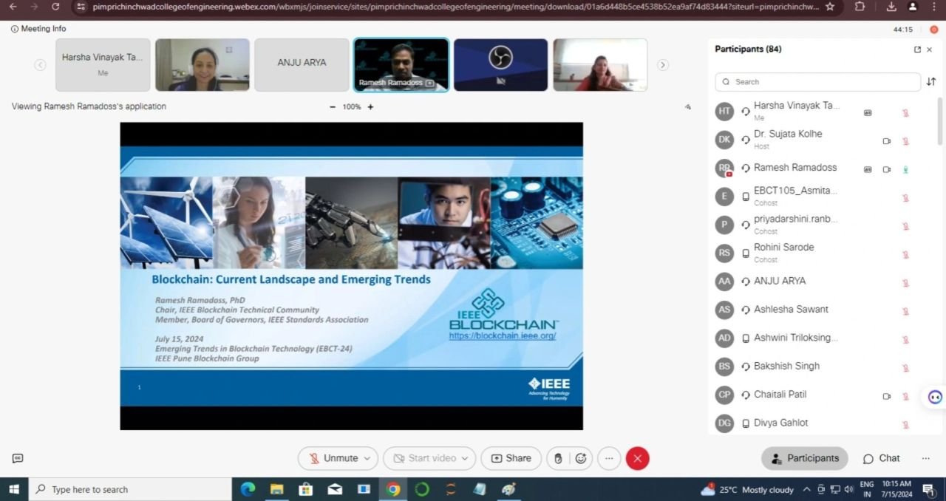
#Blockchain #STTP #ISTE #IEEE #PCET #PCCoE #Blockchain #CDAC

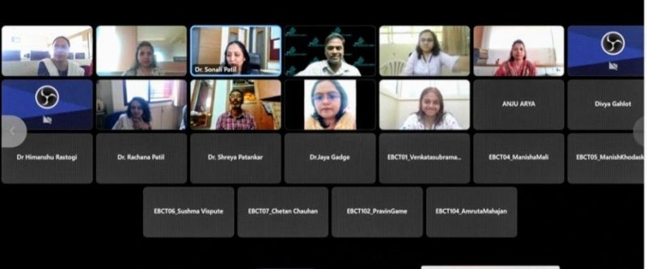

Post - 13
Delivered a talk at National Level one week FDP on "SecureChainCityCoin: A Convergence of Blockchain in Smart Cities" in association with IEEE Pune Blockchain Group and SoftTech Data Securities scheduled from 18/03/2024 to 22/03/2024.

Congratulations Team MMCoE on successful organization of the FDP and getting associated with #IEEE_Pune_Blockchain_Group

#Blockchain #IEEE #IEEE_Pune_Blockchain_Group #IEEE_BCTC
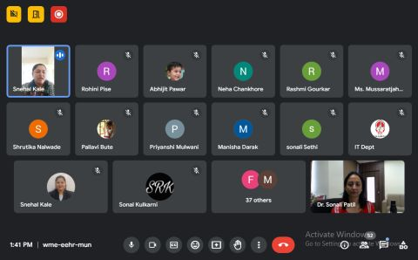
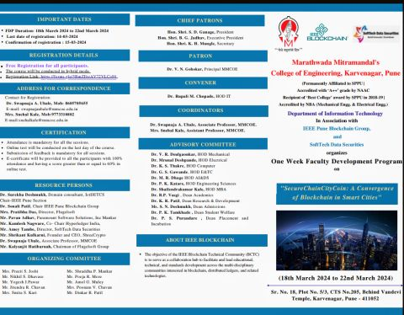
Post - 14
#Women_In_Blockchain_2024 #Hyperledger_Foundation #Hyperledger_India_Chapter
Excited to be a part of the event!!!
Women in Blockchain Season- V, 2024!
hosted by Hyperledger India Chapter & Hyperledger Foundation.

We, Deepika Karanji, Ritu Jain (She/Her), Anasuya Threse Innocent PhD, Nidhi Singh, Kartikey Kashyap, Kamlesh Nagware, Vikram Sharma, Ravi Pratap S. & Aditya Joshi - the leading members of Hyperledger India Chapter invite you all for the 5th consecutive year of celebrating women in blockchain!

In this series, you will hear from eminent women working in the field of Blockchain, both technically and non-technically share their views on it. There will be engaging and insightful panel discussions, presentations of research works, fire-side chats, and networking sessions with folks around the world.

Date: 16th March 2024, 10:00 am - 5:20 pm IST

Register Now: https://lnkd.in/gPpZu48N

Come, Let's celebrate the Womanhood!

Daniela Barbosa | Karen L. Ottoni | Min Yu

#blockchain #womeninbusiness #womenintechnology #hyperledger #hyperledgerindiachapter

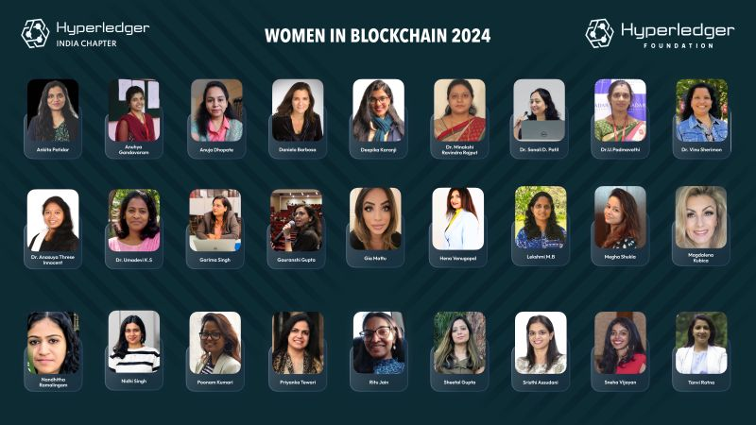
Ankita Patidar | Anuhya Gandavaram | Anuja Dhopate | Deepika Karanji | Dr. Minakshi Rajput | Dr. Sonali D. Patil | PADMAVATHI U | Dr. Vinu Sherimon | Anasuya Threse Innocent PhD | Umadevi K.S | Garima Singh | Gauranshi Gupta | Gia Mattu | Hena Venugopal | Lekshmi M B | @Megha Shukla | Magdalena Kubica | Nandhitha Ramalingam | Nidhi Singh | Poonam Kumari | Priyanka Tewari | Ritu Jain (She/Her) | Sheetal Gupta | Sristhi Assudani | Sneha Vijayan | Tanvi Ratna Hyperledger India Chapter Student Society

Post - 15
Delighted to share the success of the "Blockchain Symposium" organized by IEEE Pune Blockchain Group in collaboration with IEEE Pune Section, hosted at Pimpri Chinchwad College of Engineering, Pune!

🗓️ Date: 2nd Feb 2024

📍 Venue: Pimpri Chinchwad College of Engineering, Pune

🌐 A heartfelt thank you to our amazing speakers who shared their profound insights:
Ramesh Ramadoss, PhD Dr Surekha Deshmukh Dr. Rajesh Ingle Dr. Krishna Murthy Bulusu Dr Padmaja Patwardhan Joshi Kamlesh Nagware Pavan Adhav Shreekant Kulkarni Shruti Kulkarni Vishnu Korde Priyanshu Pareek Mehul Gaidhani Atharv_Sabnis

The topics spanned the spectrum of blockchain landscape, emerging trends and beyond!

My heartfelt appreciation goes to the enthusiastic participants who actively contributed, and the dedicated volunteers who worked tirelessly to make every aspect of the event seamless!

Special thanks to PCET Management and Director PCCOE for their guidance and support.

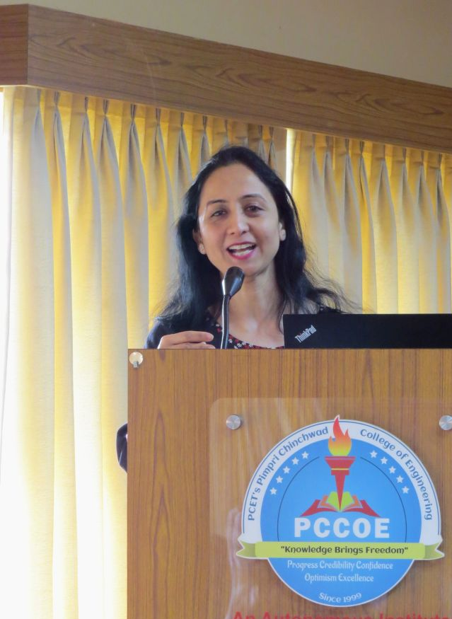
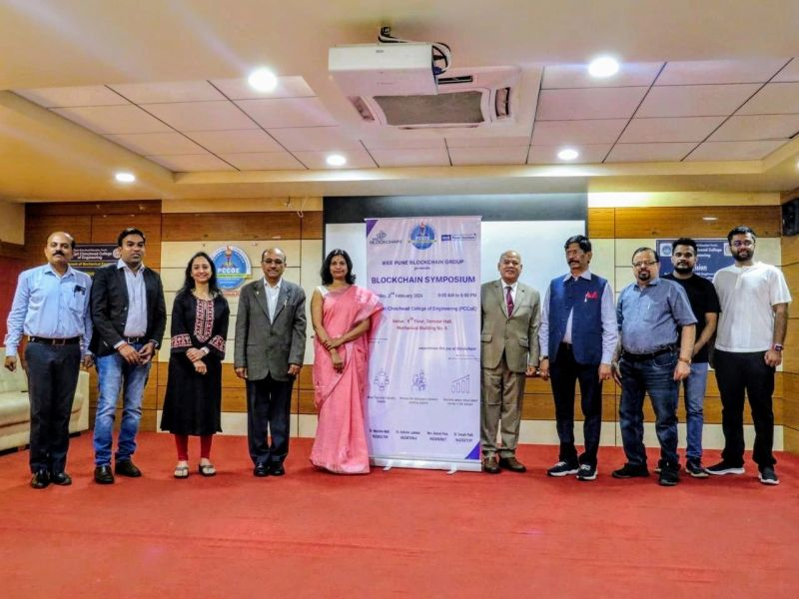
Stay tuned for more updates at IEEE Pune Blockchain Group, and let's continue to foster innovation and collaboration in the dynamic world of blockchain! #IEEEPuneSection #BlockchainSymposium #ieee #PCCOEPune #IEEEPuneBlockchainGroup #IEEEPuneSection #IEEEBlockchain #pcet

Post - 16
#Blockchain_Symposium by IEEE Pune Blockchain Group on 2nd February 2024, Friday at PCCOE PUNE.
#Sessions, #paneldiscussion #demonstrations #PoCs #Usecases
Don't miss the opportunity to meet the speakers: Ramesh Ramadoss, PhD Dr. Rajesh Ingle Dr Surekha Deshmukh Dr Padmaja Patwardhan Joshi Kamlesh Nagware Shreekant Kulkarni Pavan Adhav Vishnu Korde Shruti Kulkarni Priyanshu Pareek
#Registernow at:
https://lnkd.in/d2cdQX7v
#IEEE #blockchain #pccoe #symposium #ieeepunesection #ieeeblockchaingroup
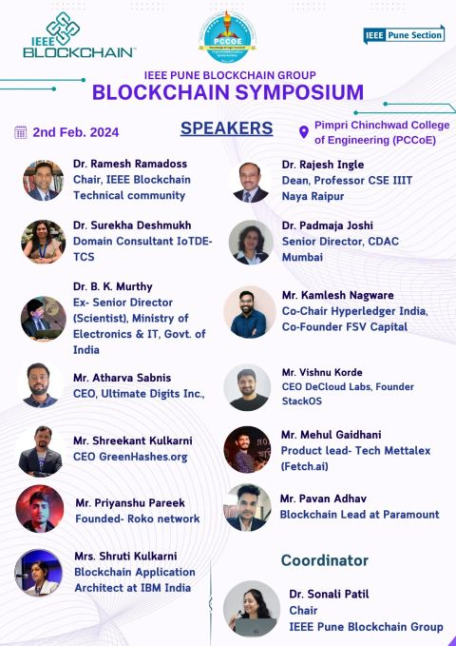
Post - 17
Attending the IEEE Conference ICBDS 23 at IIIT Naya Raipur was a truly humbling and enriching experience.

I had the privilege of serving as the Tutorial Chair and Session Chair, as well as contributing as a Paper Author and being honored with the Best Paper Award.

The conference provided an opportunity for me to engage in insightful discussions and interact with esteemed experts in the Blockchain field. The beautiful IIIT, NR campus backdrop only added to the overall experience, making it a truly memorable event.
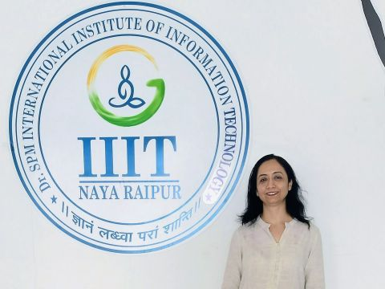
#IEEE #Blockchain #ICBDS #Conference
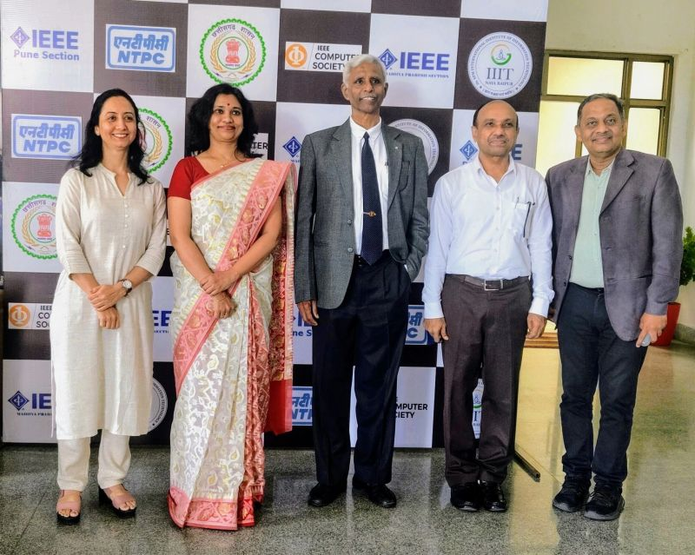

Post - 18
ongratulations on the formation of the "IEEE Pune Blockchain Group" under IEEE Blockchain REGION 10 Asia-Pacific! (https://lnkd.in/dXXMa2wt).
The mission of the proposed blockchain local group is to bring together professionals interested in networking, learning, sharing, and advancing technology. The local group plans to organize meetups, events, lectures, seminars, workshops, and other activities (in person or virtual).
I express my gratitude to Ramesh Ramadoss, PhD, Chair-IEEE Blockchain, and Dr Surekha Deshmukh, Chair-IEEE Pune Section for their support and approval of this initiative.
I encourage you to connect and contribute:
Prof. Dr. Sonali Patil, Chair, IEEE Pune Blockchain Group
[IEEE Senior Member #93890098]

Post - 19
Indeed a wonderful experience to share insights and interact with Ph.D. #Research_Scholars on "#Blockchain: Recent Trends and Research Opportunities" at University Technology Petronas (#UTP) in #Malaysia.

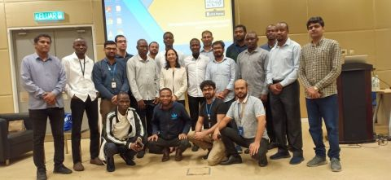
#experttalk #blockchain #ieee #pcet #pccoe #utp #malaysia
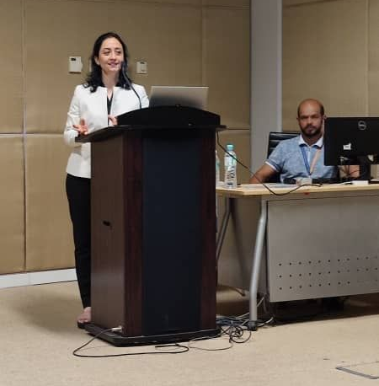

Post - 20
Delivered a session at one week Faculty Development Program on "Relevance of Blockchain and dApps in Current Trends" organized by Vishwakarma Institute of Information Technology in association with IEEE Computer Society, Pune Chapter.
#blockchain #recent_trends
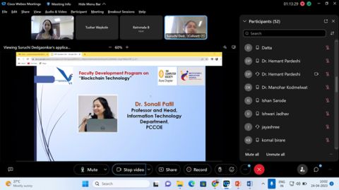
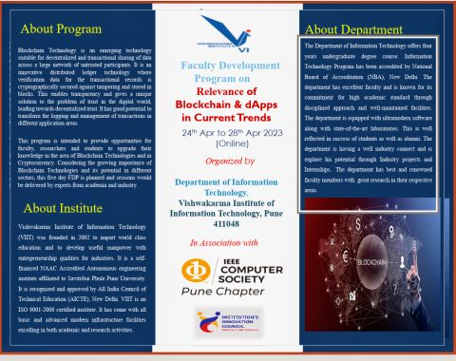

Post - 21

